##### Image Printed Calendar

##### 

**Price: Rs.1200/-**

Custom mini small wooden perpetual calendar.

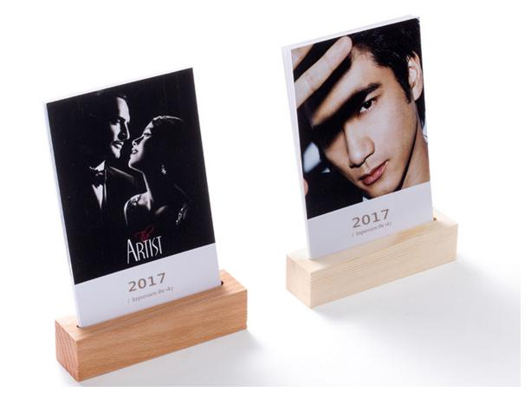

* Model Number: 20785856119
* Type: Printing Calendar
* Promotional: No
* Style: Table Calendar
* Display Screen: show as the picture
* Use: wood calendar
* Origin: china
* Color: Show as the pictures
* Size: 6.5cm x 12cm x 5cm
* Type 1: Table Calendar
* Type 2: Wooden Calendar